Renju lesson on October 25, 2001
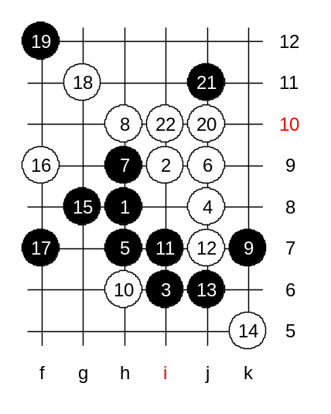
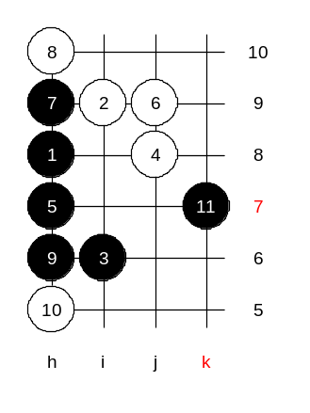
Hello everyone! Welcome to Online Renju Class. We will now begin. Today we will continue the study of i8 opening. We have 3 more 4th moves to study. We will take the easier ones first. 4-j8. It is a famous gambling move in i8 opening. Remember, there are lots of traps, so you have to be very careful when you play it as black. And when you are white, try to playing only against those who do not know the following moves. In case of correct moves, black wins. About the 5th moves, which are the best? The main 5th move is h7, you are right about it. Black wins very fast. We can use the control style – h9. White defends at h6 – the strongest. Let’s win together. Tell me the steps please. If we forgot to play 17-f8 first then white can cut as shown on this diagram.

But in case of i8, we will have another cut.
So, how to do?
Well, it seems your first attack failed. I give you another try. I know an easy answer. We just need to play a four to h6 first.

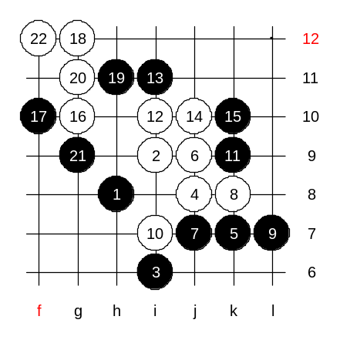
Now, we will study another 5th move. Where is the best? Yes, I totally agree about k7. Moves 5-h6 and 5-k10 have not been studied deeply enough, so we do not know the conclusion there.
5-k7. Then, 6-j9 again, it is white’s only chance. The majority here suggests 7-j7. Well, in my opinion it is a bad move. We will see the weakness of black structure.

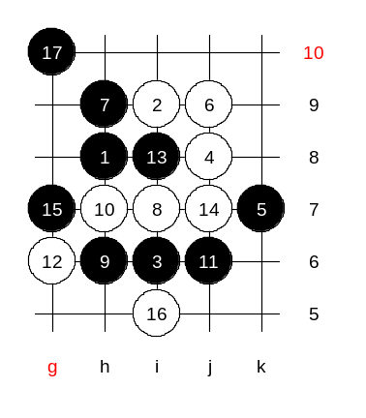
Now we will learn the correct way. 7-h9. Then 8-i7 – the best. Now, there are some choices for 11th move. In my opinion, the strongest move is j6. In case of 11-g6, black must be very careful because white has lots of traps there.
So we play 11-j6. There is a forced variant up to move 16. Some books mention 17-j11, but I think black should be more straight and play 17-g10. In my analysis, black wins everywhere. Since the position is very interesting, we will study it at home later.
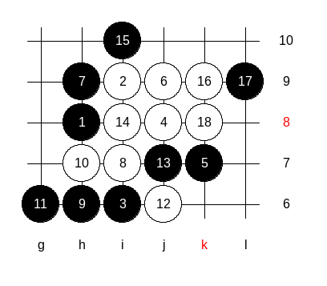
Now, we will study the other 11th move, too.
Lets play 16-k9 – a famous gamble. Majority chose 17-L9, the losing one. :) Now finished, white won.

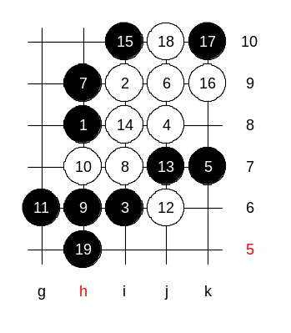

I will now show you the correct move.
Move 17-k10 is the only move. However, black must still be careful.

